Smart Lighting Engineering Research Center Summer 2015

Timothy Kendall Waryas Jr.

IEA - Light Mixing/Intro to PWM

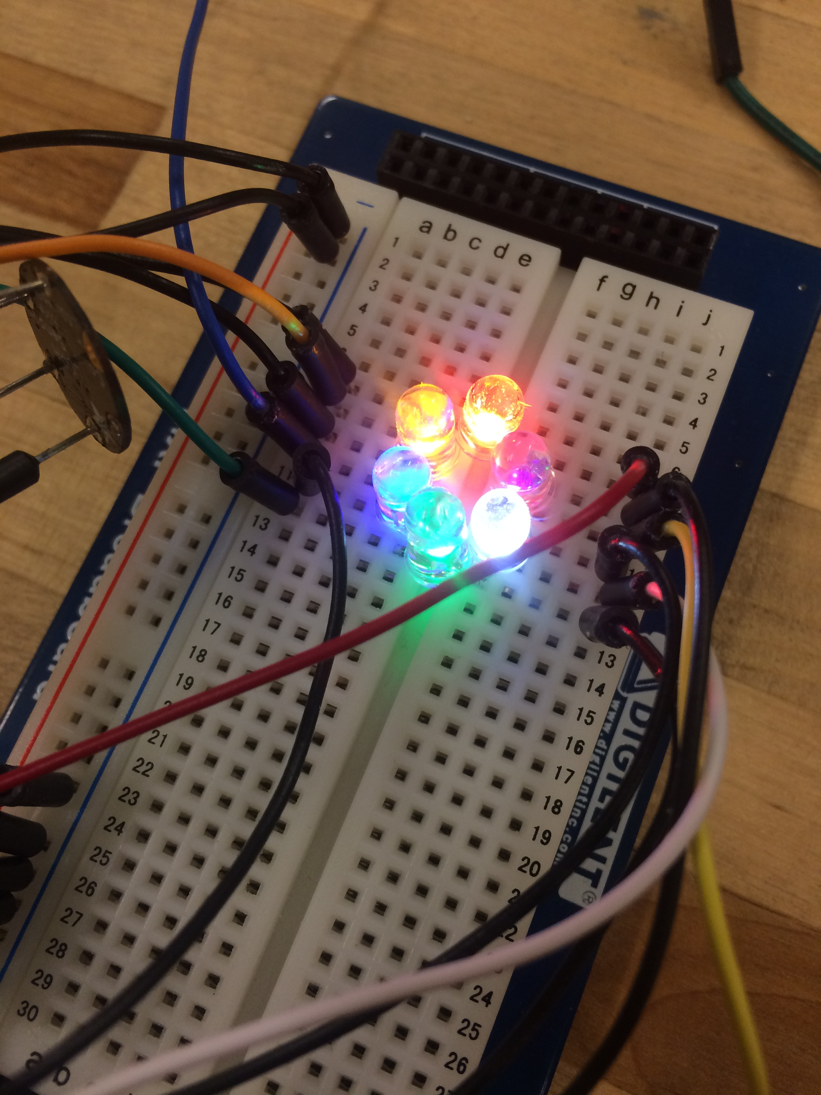

**Intro:**

Light mixing can be modeled as a simple matrix algebra problem. Each channel of light can be modeled as a vector, and concurrently a column in a matrix. Each value S with its respective subscript to its color represents an intensity/weight of the light present in the final mixture $S_{New}$. A setup of the matrix multiplication (although not necessarily needed to see that the final vector is just a column of the intensities) is shown below. http://www.cs.cornell.edu/courses/cs465/2005fa/lectures/23color/23color.pdf

$$\left[\begin{matrix}⋮ \\ ⋮ \\ \begin{matrix}S_{New} \\ ⋮ \\ \begin{matrix}⋮ \\ ⋮\end{matrix}\end{matrix}\end{matrix}\right]=\left[\begin{matrix}\begin{matrix}S_{R} & 0 & 0 \\ 0 & S_{G} & 0 \\ 0 & 0 & S_{B}\end{matrix} & \begin{matrix}0 & 0 & 0 \\ 0 & 0 & 0 \\ 0 & 0 & 0\end{matrix} \\ \begin{matrix}0 & 0 & 0 \\ 0 & 0 & 0 \\ 0 & 0 & 0\end{matrix} & \begin{matrix}S_{A} & 0 & 0 \\ 0 & S_{W} & 0 \\ 0 & 0 & S_{V}\end{matrix}\end{matrix}\right]*\left[\begin{matrix}R \\ \begin{matrix}G \\ B \\ \begin{matrix}A \\ W \\ V\end{matrix}\end{matrix}\end{matrix}\right]$$

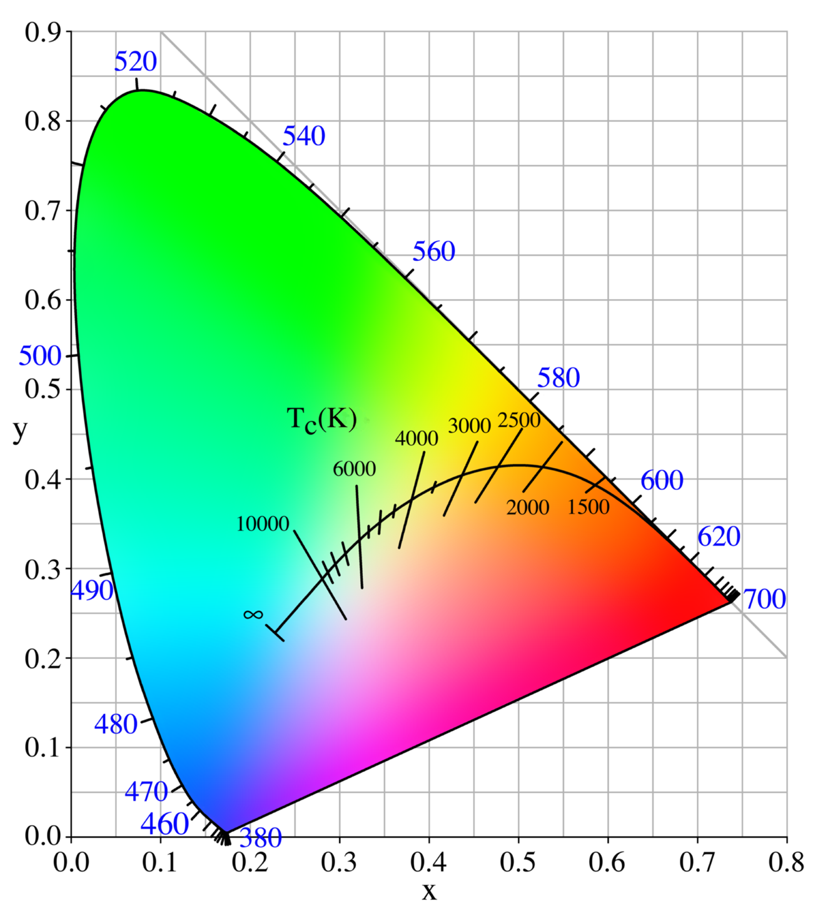

$$\left[\begin{matrix}⋮ \\ ⋮ \\ \begin{matrix}S_{New} \\ ⋮ \\ \begin{matrix}⋮ \\ ⋮\end{matrix}\end{matrix}\end{matrix}\right]=\left[\begin{matrix}\begin{matrix} & \begin{matrix} & \end{matrix} \\ & \begin{matrix} & \end{matrix}\end{matrix} & \begin{matrix} & \begin{matrix} & \end{matrix} \\ & \begin{matrix} & \end{matrix}\end{matrix} \\ \begin{matrix} & \begin{matrix} & \end{matrix}\end{matrix} & \begin{matrix} & \begin{matrix} & \end{matrix}\end{matrix}\end{matrix}\right]*\left[\begin{matrix}R \\ \begin{matrix}G \\ B \\ \begin{matrix}A \\ W \\ V\end{matrix}\end{matrix}\end{matrix}\right]$$

**\*\*Pick and choose a single value RGBAWV to find the 3x6 matrix**

Find a lens to mix everything.

**Equipment/Terminology:**

The National Instruments MyRio 1900 Microcontroller (left) will be used to control the different channels of LEDs needed to produce a specific color of light, as well as to read the RGB sensor (right) across an $I^{2}C$ bus.

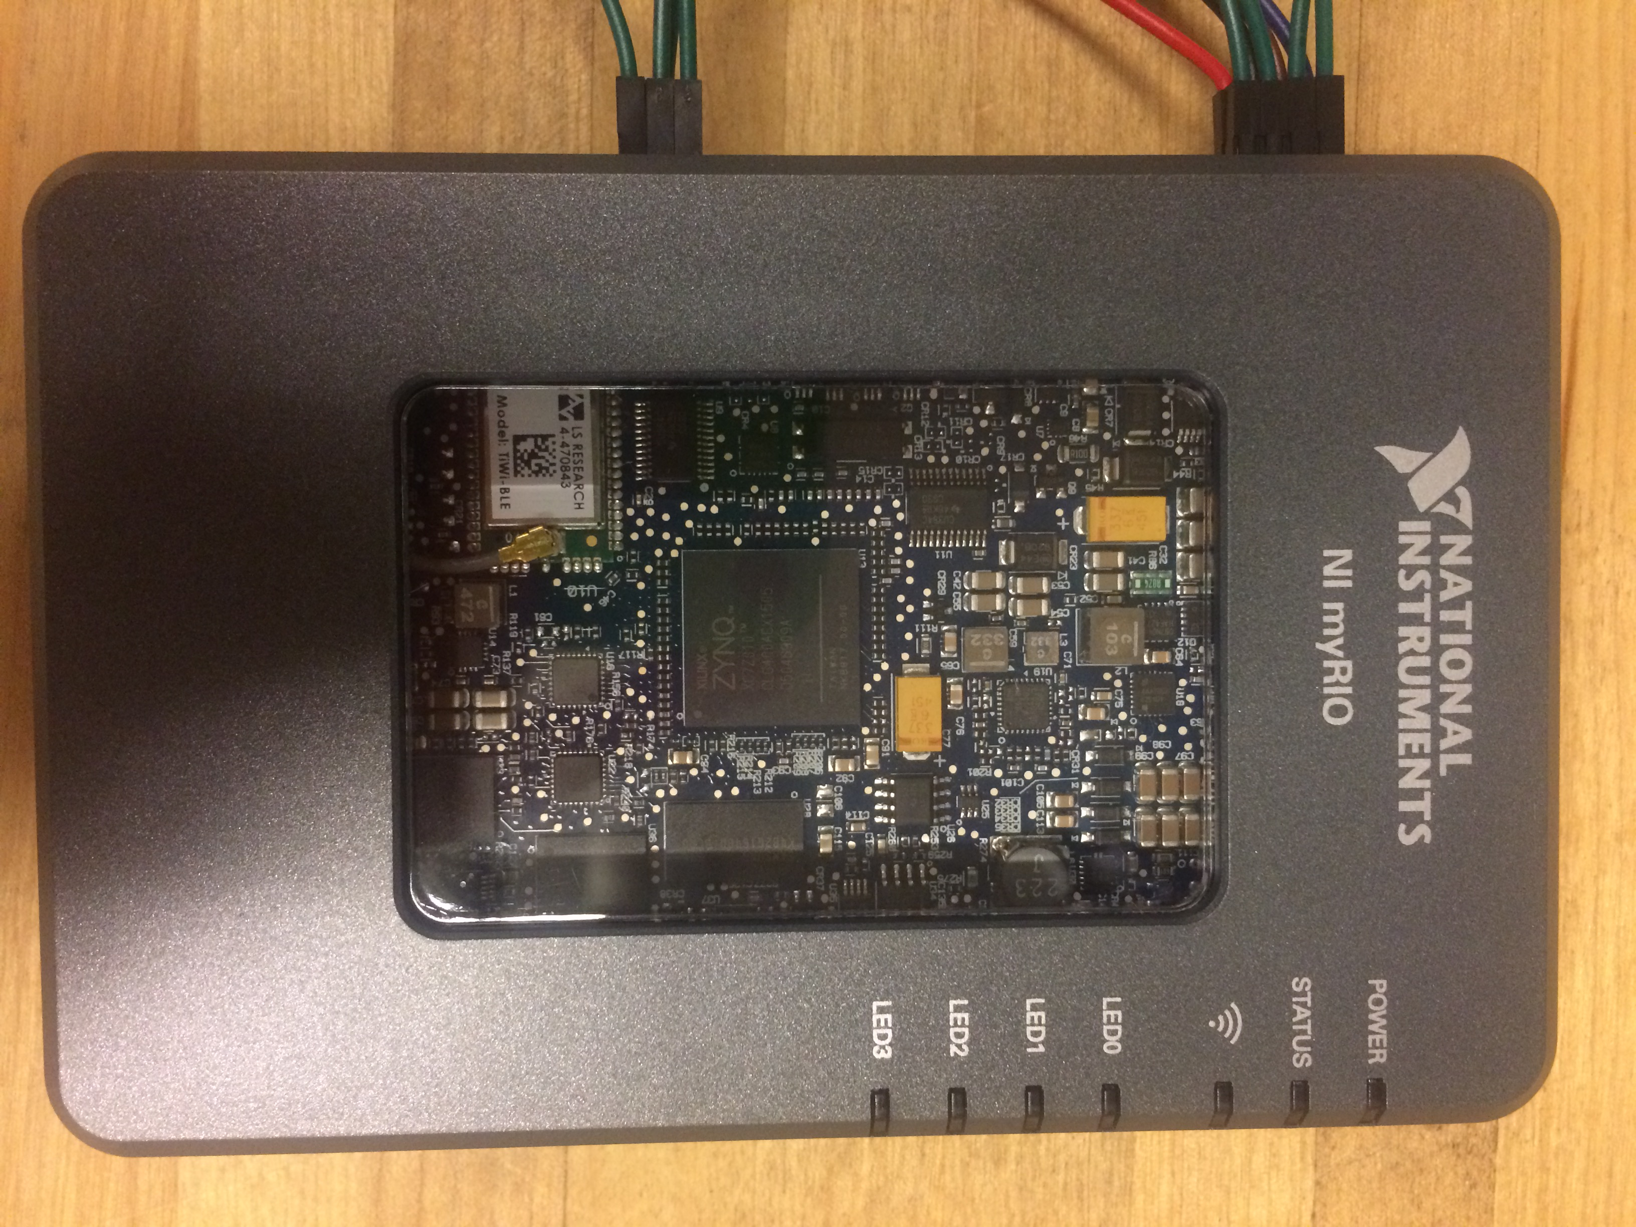

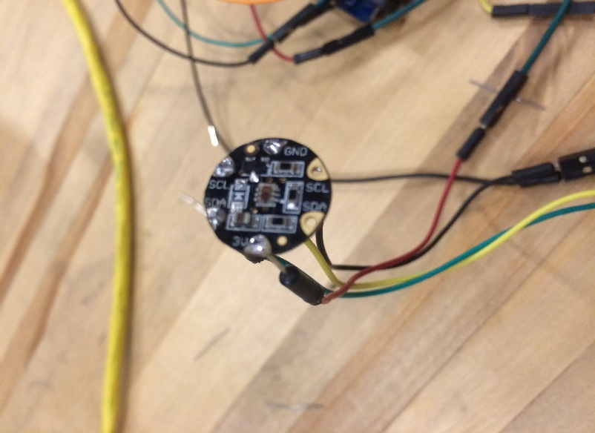

The LEDs will be controlled with Pulse Width Modulation (PWM). This allows for a varied voltage by changing the duty cycle of the voltage step function on the PWM pins. Changing the percentage of the cycle produces a linear fraction of the total amplitude of the voltage (3.3V) when set to a relatively high frequency. The duty cycle being how long the pin stays at 3.3V during one period before dropping back down to 0V. If there is a long duty cycle say 90%, this means that the pin is at 3.3V for 90% of its period. When at a high frequency, this will average out quite nicely and appear to be a constant voltage. In this case the voltage on the pin will be 90% of 3.3V, so approximately 2.97V. Having the ability to easily vary DC voltage digitally is imperative in LED control.

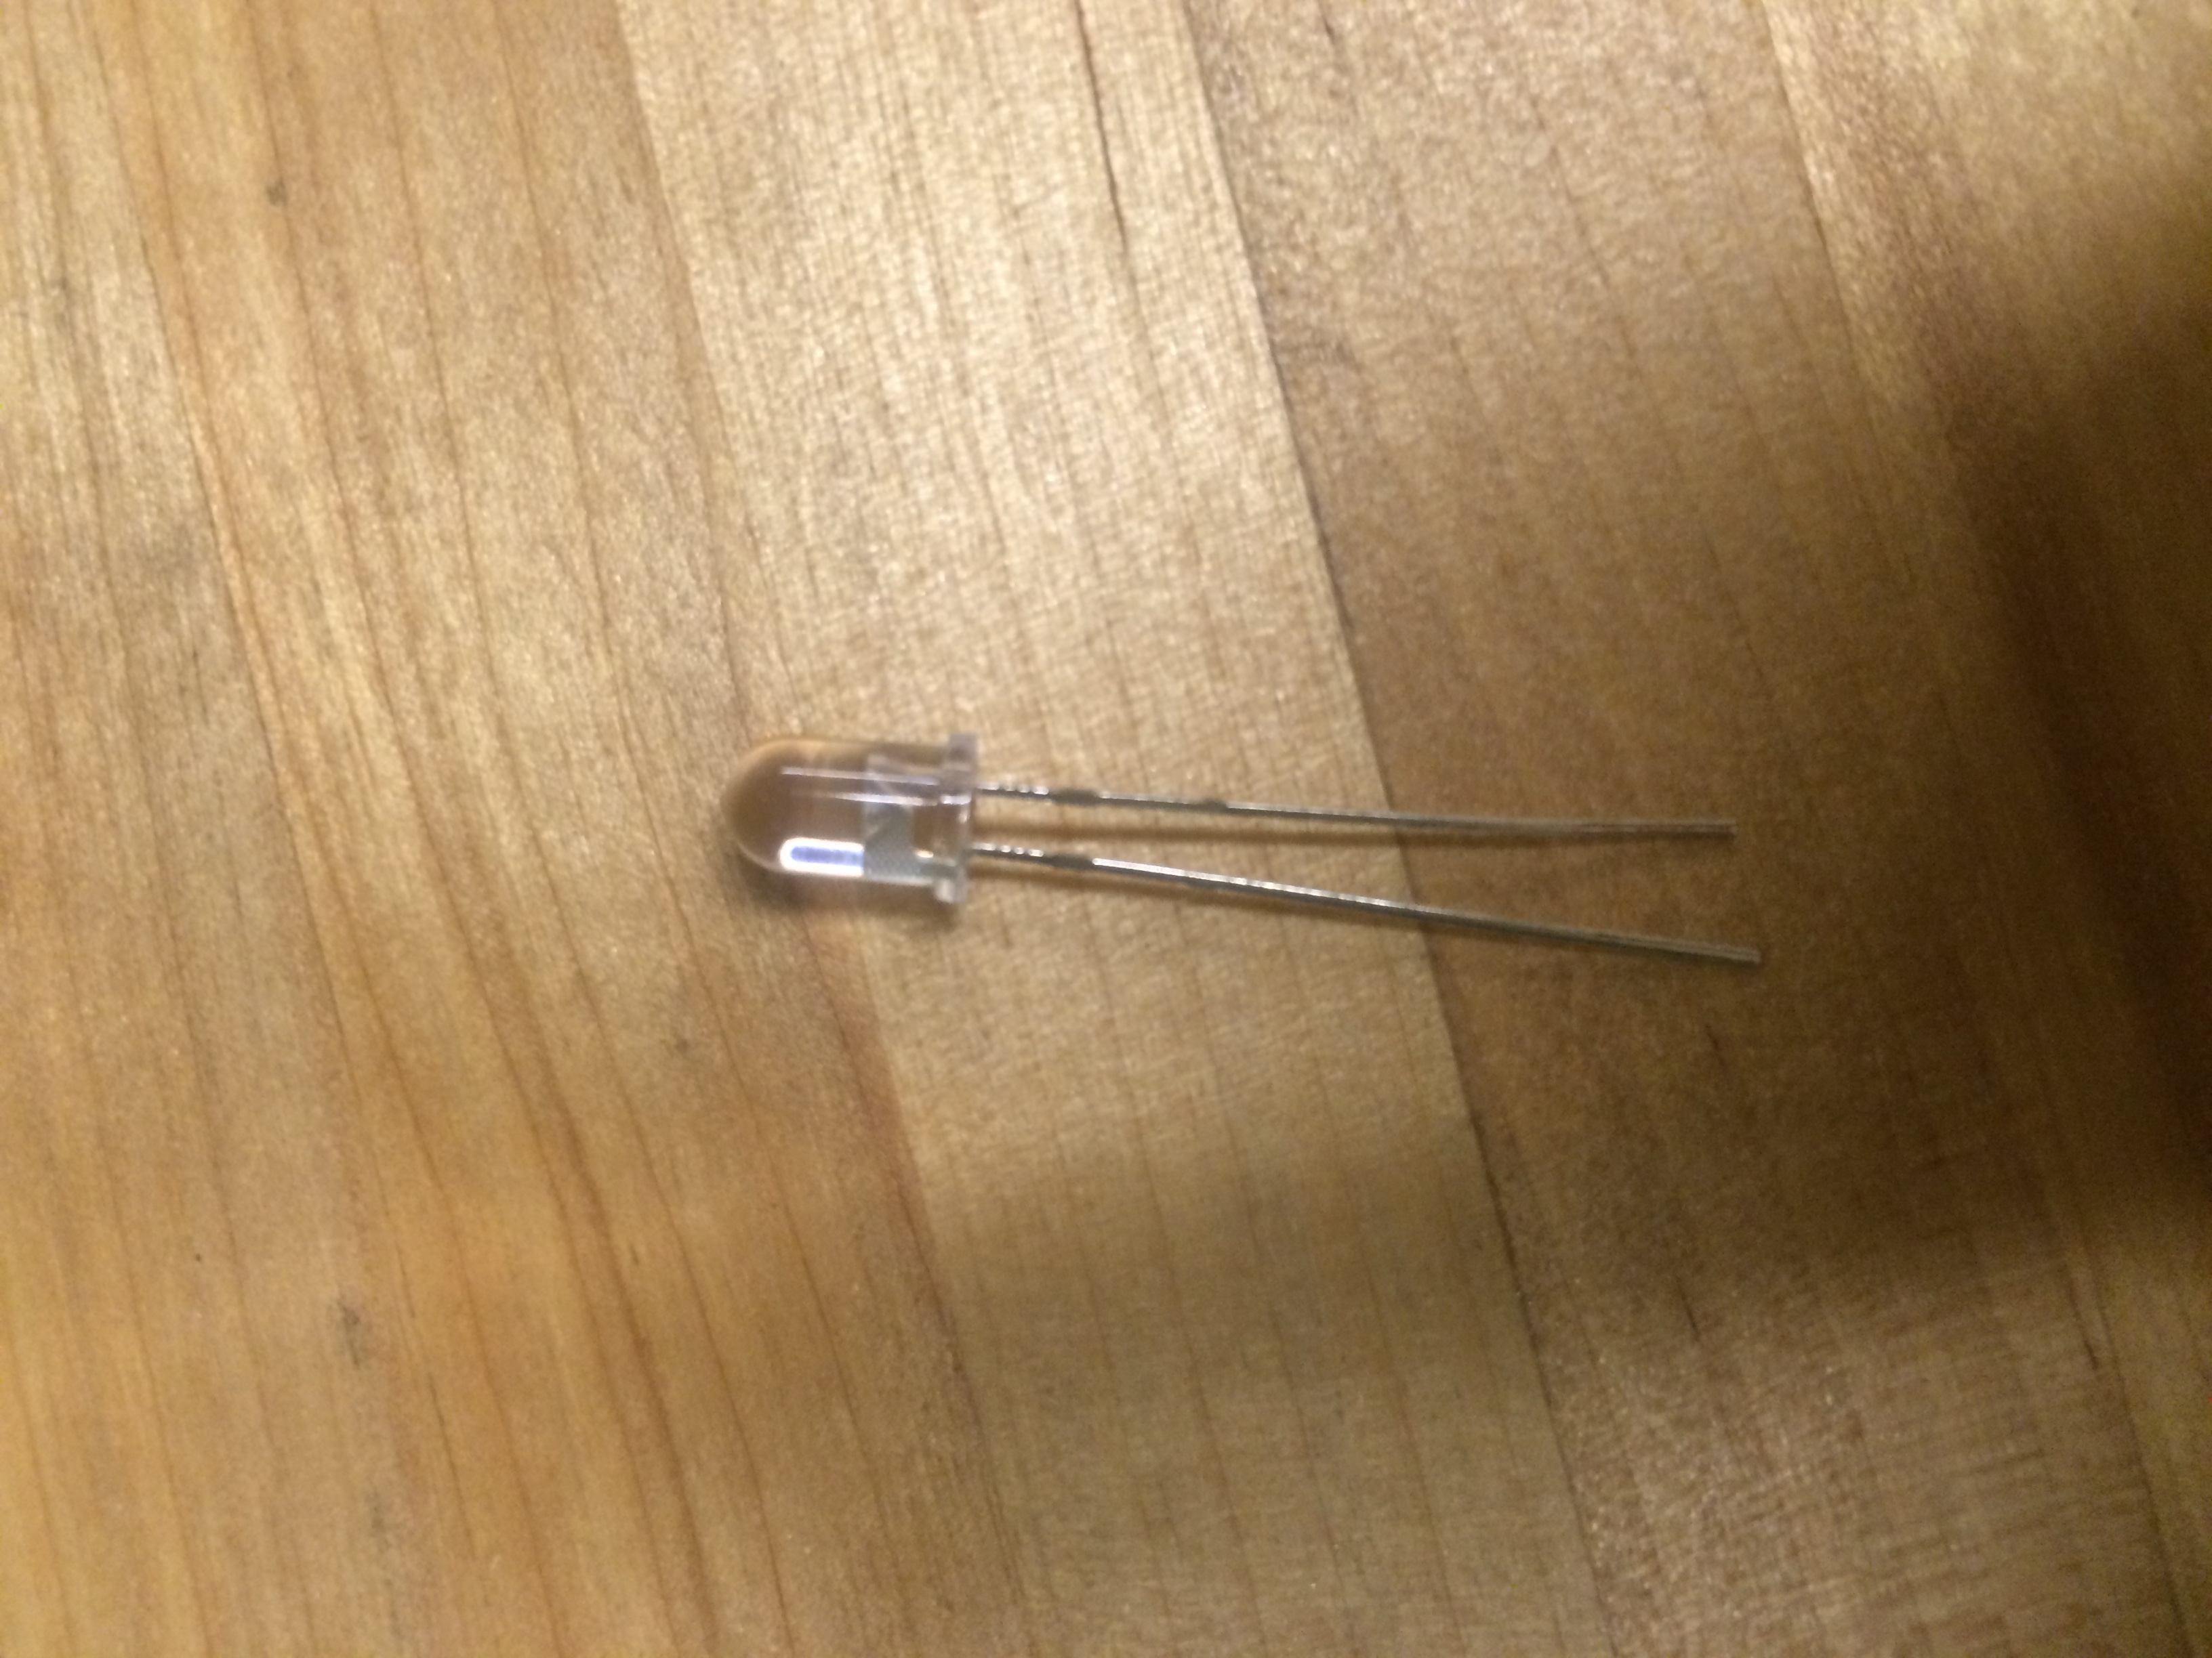

LEDs are polar circuit components, i.e. the pins on the devices need to be respectively set to a high and a low voltage to produce light. The positive terminal on the type of LED shown above, or the anode is the longer pin. The negative terminal is the shorter, or the cathode. When there is a voltage difference across the two, with the anode set to high, light will be produced. Different colored LEDs have different head voltages and currents, or basically the maximum operational power the LED should be subjected to. Longer wavelength LEDs, i.e. red spectra tend to have much lower head voltages than shorter wavelength/high frequency light (blue). Current through an LED will increase exponentially will even small changes past the head voltage. **NOTE the virtual instrument created for this lab contains sliders which max out at the head voltages for specific LEDs, the correct pins for the correct LEDs must be used to avoid subjecting an LED to too high of a voltage, make sure the TA has checked.

**Parts List:**

MyRio-1900 Microcontroller

Breadboard

[**http://www.digikey.com/short/tzvn72**](http://www.digikey.com/short/tzvn72)- LEDs for sale

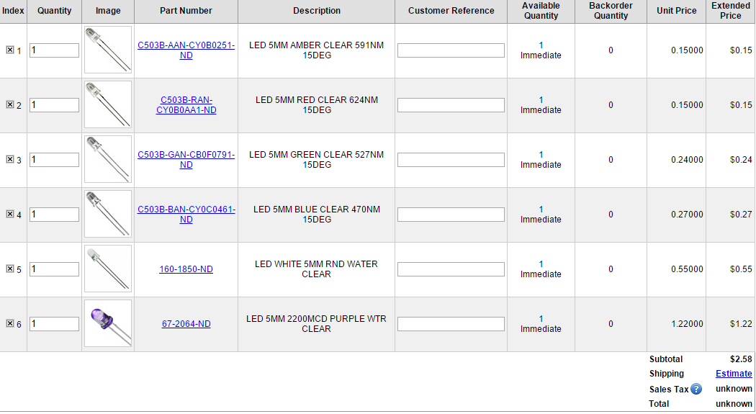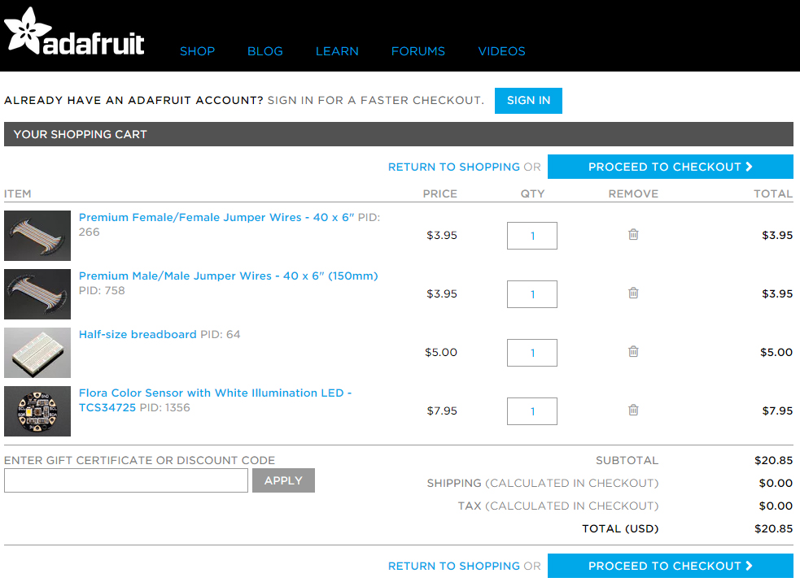

**Setup:**

There are 3 PWM pins per expansion port on the MyRIO. During the lab both ports A and B will be utilized to access 6 PWM pins in total, allowing for 6 channels of different colored LEDs.

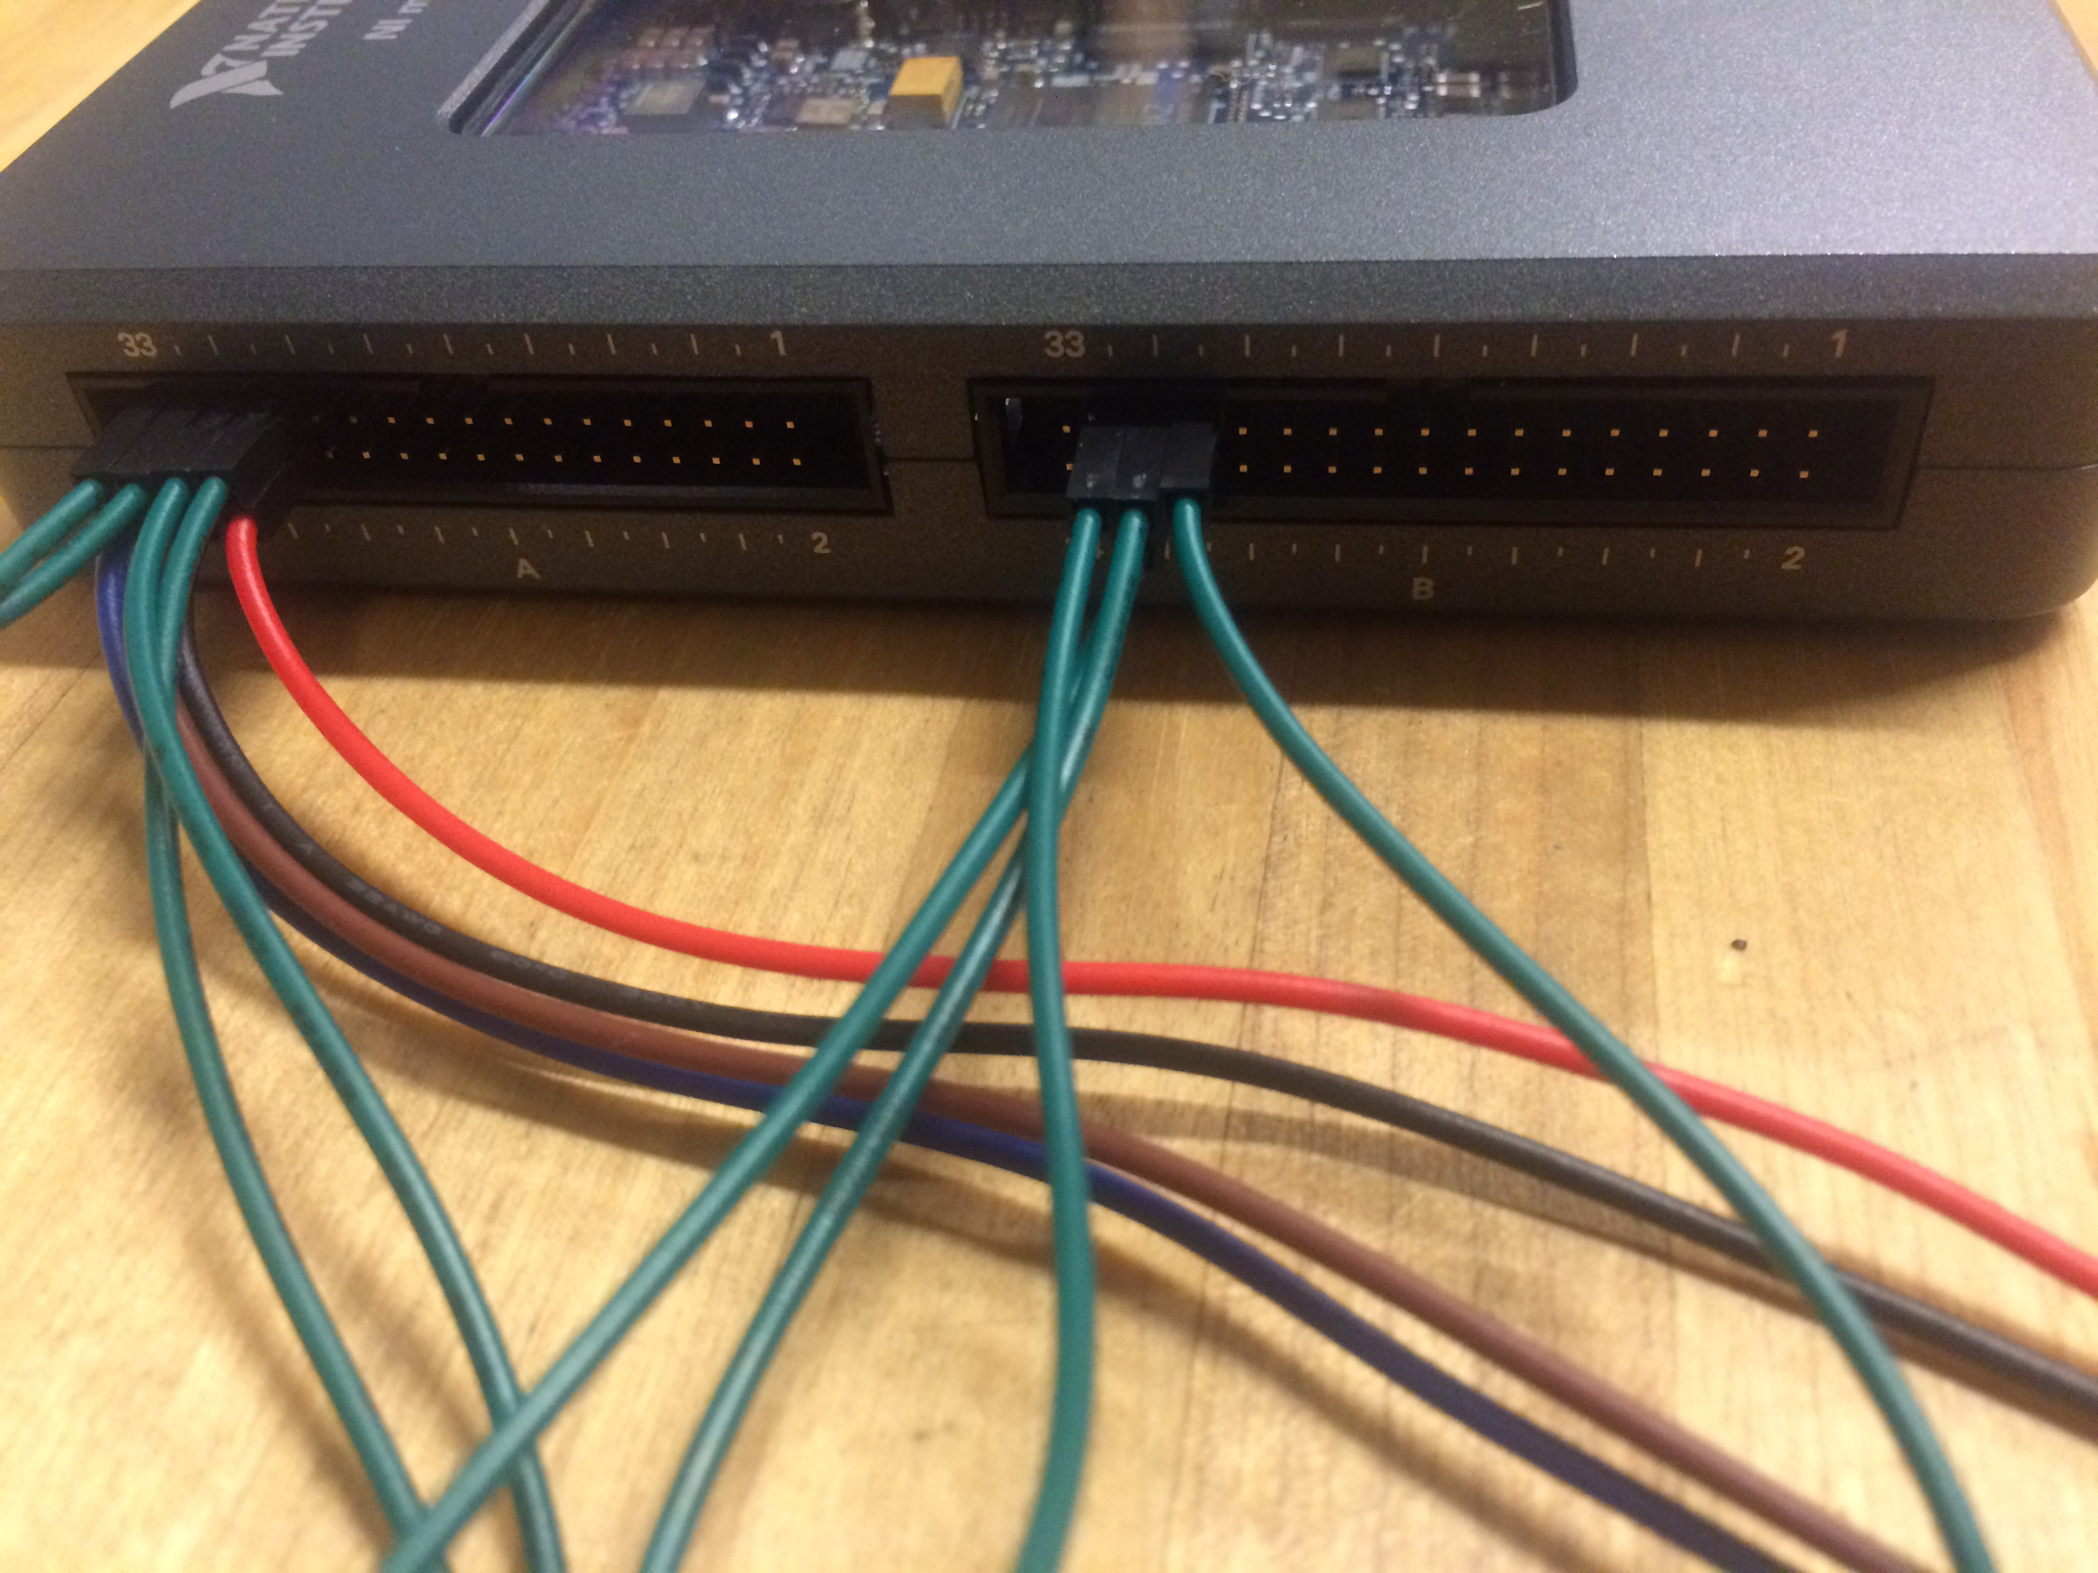

Expansion port A is on the left in the picture above, port B is on the right. Pins 31, 29, and 27 are the PWM pins on both ports. The LEDs should be arranged in a hexagonal pattern shown below on the breadboard. (With breadboards all of the rows are at the same voltage, the two columns out on the edge are at the same voltage as well.)

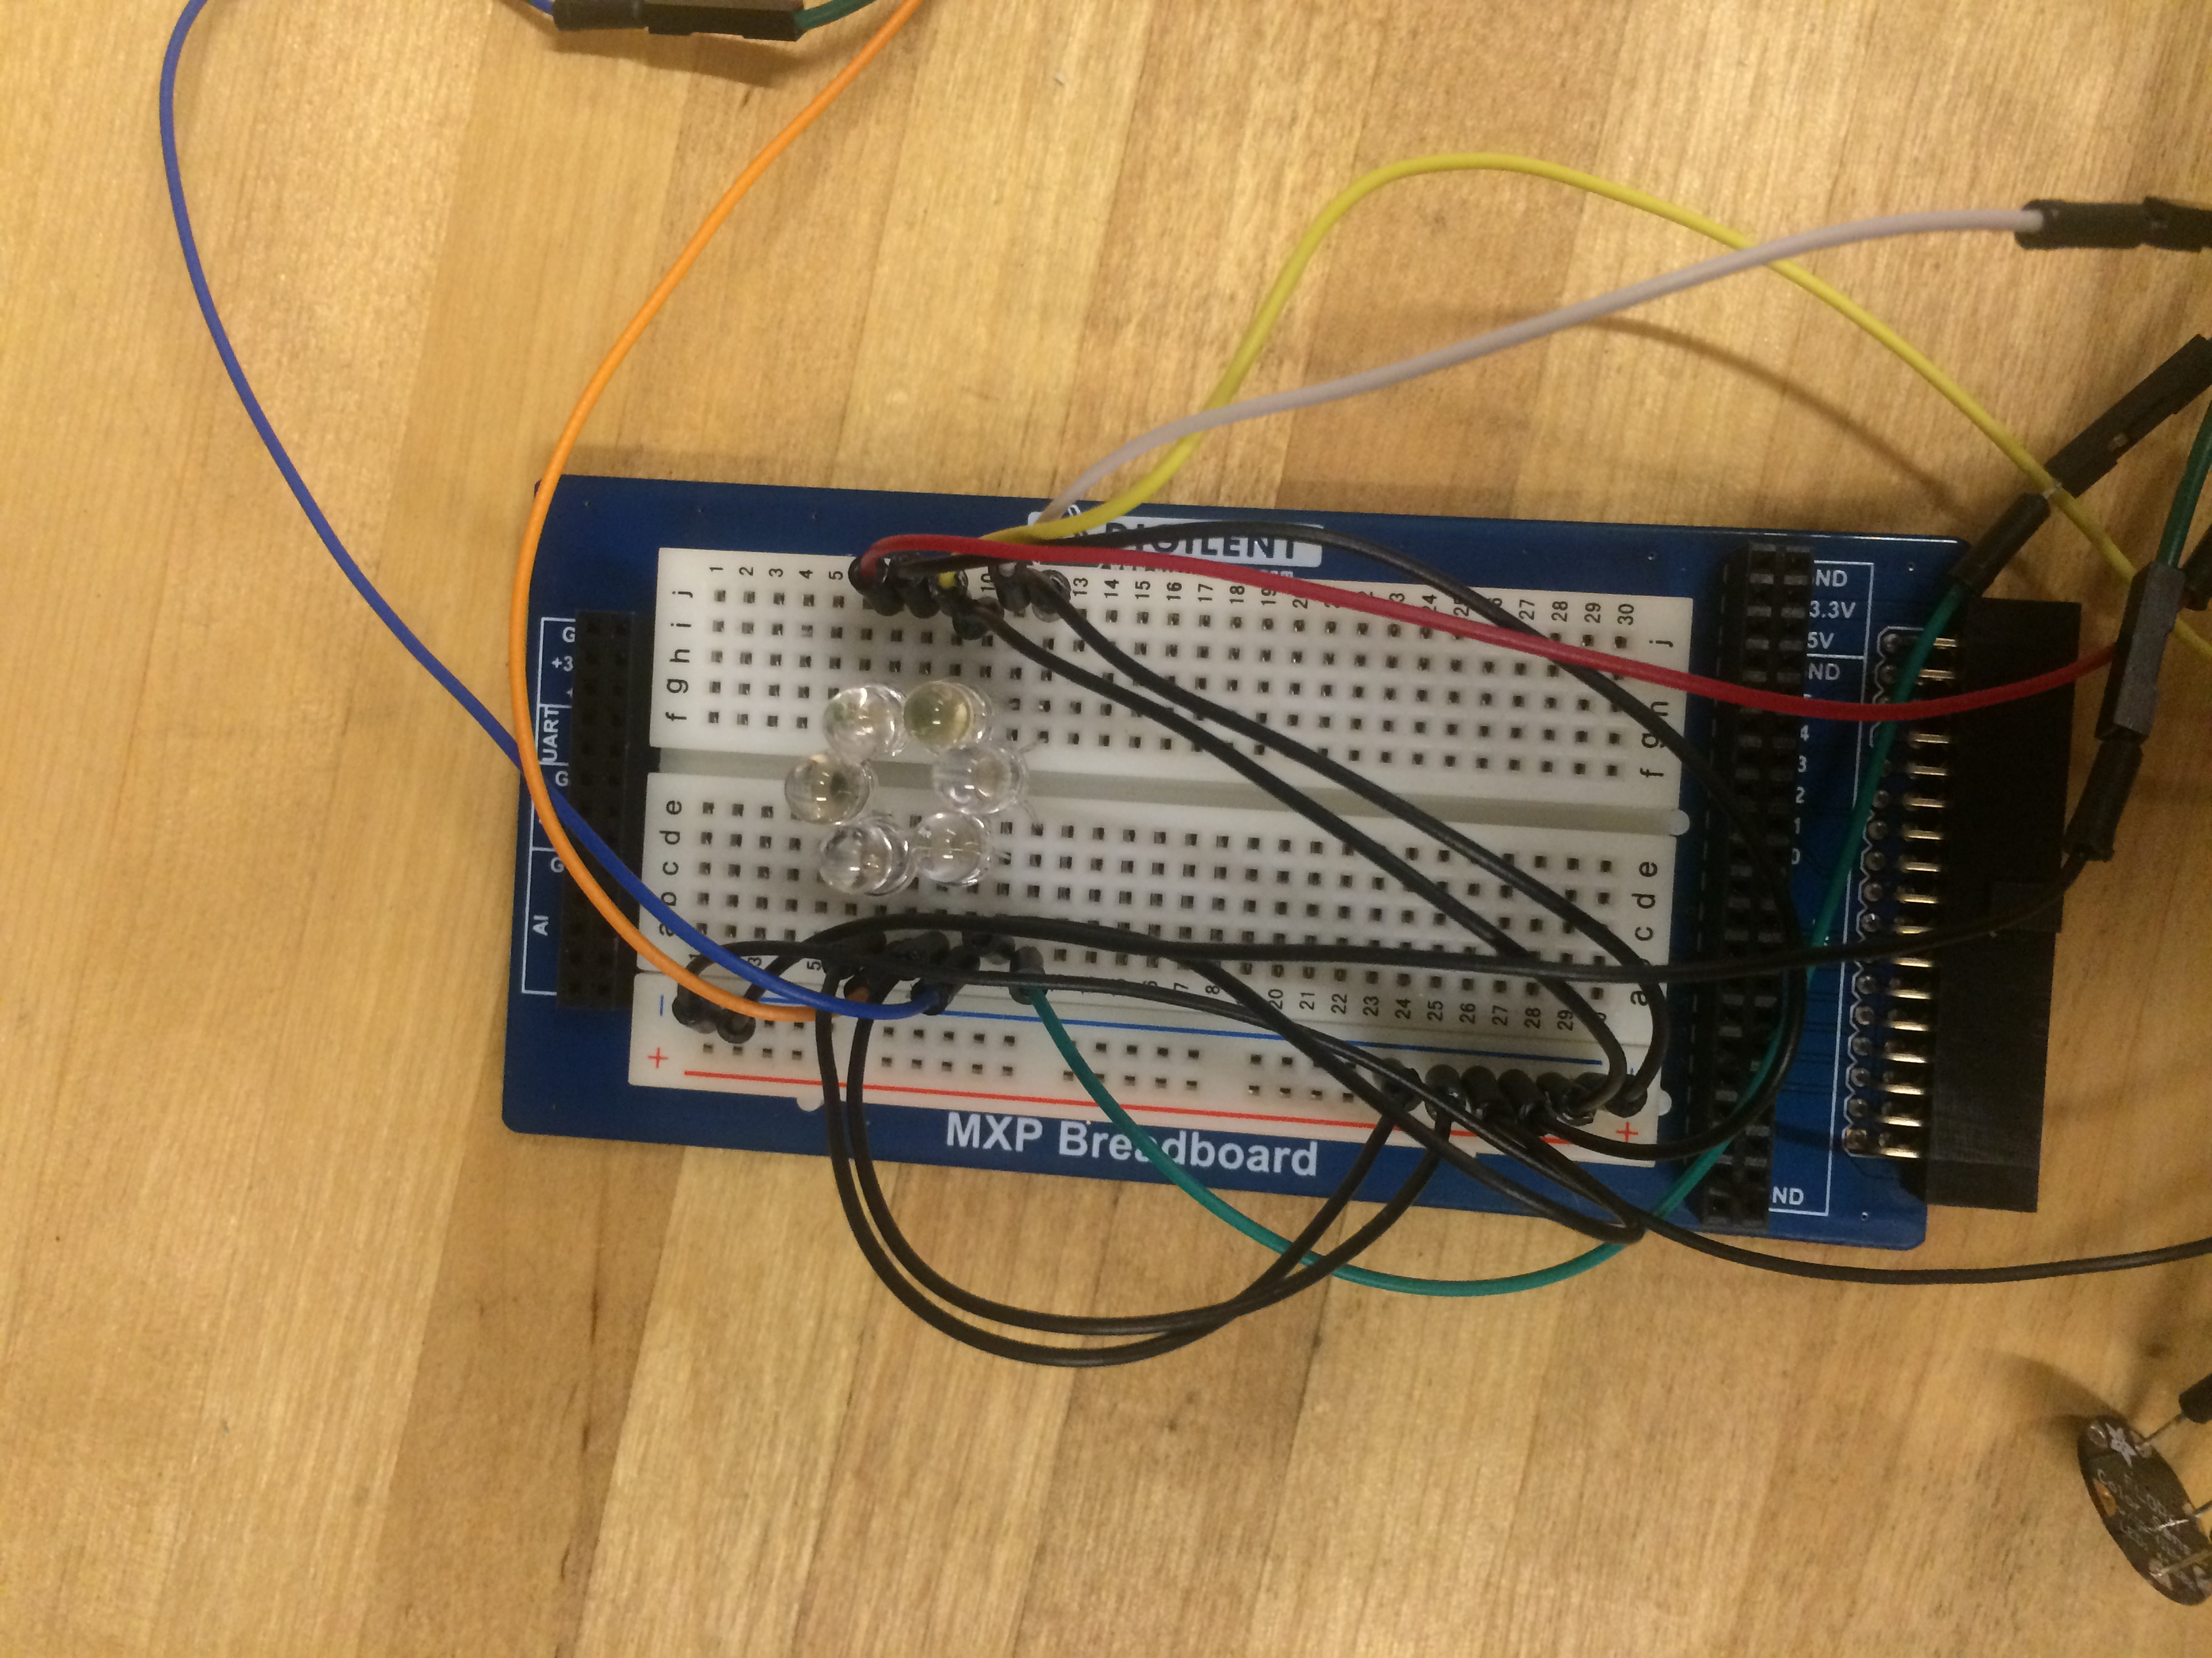

Below is a table of which pins should be connected to which anode of its color’s LED, all cathodes should be connected to ground.

|  |  |
| --- | --- |
| Pin | LED Color |
| 31/A | Blue |
| 29/A | Green |
| 27/A | Red |
| 31/B | Amber |
| 29/B | White |
| 27/B | Violet |

On both of the expansion ports there are several ground pins. All cathodes of LEDs should be connected to the same column and the column be grounded on at least two of these pins. Below shows the labels for the pins.

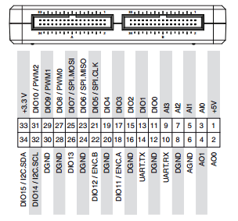

Next comes the connection of the RGB sensor. On the sensor board itself, there are 4 leads connected to 4 pins on the board, they’re labeled 3.3V, GND, SDA, and SCL. SDA and SCL need to both be connected to 34A and 32A respectively. GND connected to a free ground pin, and 3.3V connected to analog pin 33A.

After all connections are ready, check with the TA and the VI interface will be ready to go.